**PROGRAM-6**

**AIM**-Write an algorithm and program to sort n number using merge sort technique

**ALGORITHM-**

MergeSort(A, p, r):

if p > r

return

q = (p+r)/2

mergeSort(A, p, q)

mergeSort(A, q+1, r)

merge(A, p, q, r)

1. **Using normal approach i.e recursion illustrating Divide and conquer –**

**SOURCE CODE-**

#include <stdio.h>

void mergeSort(int [], int, int, int);

void partition(int [],int, int);

int main()

{

int list[50];

int i, size;

printf("How Many elements u want to Sort :: ");

scanf("%d", &size);

printf("\nEnter [ %d ] elements below to be Sorted :: \n",size);

for(i = 0; i < size; i++)

{

printf("\nEnter [ %d ] Element :: ",i+1);

scanf("%d", &list[i]);

}

partition(list, 0, size - 1);

printf("\n\nAfter implementing Merge sort, Sorted List is :: \n\n");

for(i = 0;i < size; i++)

{

printf("%d ",list[i]);

}

printf("\n");

return 0;

}

void partition(int list[],int low,int high)

{

int mid;

if(low < high)

{

mid = (low + high) / 2;

partition(list, low, mid);

partition(list, mid + 1, high);

mergeSort(list, low, mid, high);

}

}

void mergeSort(int list[],int low,int mid,int high)

{

int i, mi, k, lo, temp[50];

lo = low;

i = low;

mi = mid + 1;

while ((lo <= mid) && (mi <= high))

{

if (list[lo] <= list[mi])

{

temp[i] = list[lo];

lo++;

}

else

{

temp[i] = list[mi];

mi++;

}

i++;

}

if (lo > mid)

{

for (k = mi; k <= high; k++)

{

temp[i] = list[k];

i++;

}

}

else

{

for (k = lo; k <= mid; k++)

{

temp[i] = list[k];

i++;

}

}

for (k = low; k <= high; k++)

{

list[k] = temp[k];

}

}

**OUTPUT-**

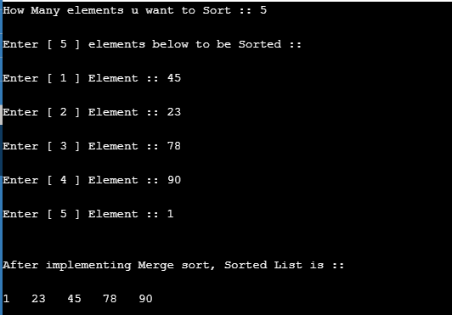

1. **Without using recursion-**

**SOURCE CODE**

#include <stdio.h>

#define MAX 30

int main()

{

int arr[MAX],temp[MAX],i,j,k,n,size,l1,h1,l2,h2;

printf("Enter the number of elements : ");

scanf("%d",&n);

for(i=0;i<n;i++)

{

printf("Enter element %d : ",i+1);

scanf("%d",&arr[i]);

}

printf("Unsorted list is : ");

for( i = 0 ; i<n ; i++)

printf("%d ", arr[i]);

for(size=1; size < n; size=size*2 )

{

l1=0;

k=0;

while( l1+size < n)

{

h1=l1+size-1;

l2=h1+1;

h2=l2+size-1;

if( h2>=n )

h2=n-1;

i=l1;

j=l2;

while(i<=h1 && j<=h2 )

{

if( arr[i] <= arr[j] )

temp[k++]=arr[i++];

else

temp[k++]=arr[j++];

}

while(i<=h1)

temp[k++]=arr[i++];

while(j<=h2)

temp[k++]=arr[j++];

l1=h2+1;

}

for(i=l1; k<n; i++)

temp[k++]=arr[i];

for(i=0;i<n;i++)

arr[i]=temp[i];

printf("\nSize=%d \nElements are : ",size);

for( i = 0 ; i<n ; i++)

printf("%d ", arr[i]);

}

printf("Sorted list is :\n");

for( i = 0 ; i<n ; i++)

printf("%d ", arr[i]);

printf("\n");

return 0;

}

**OUTPUT-**

